**MTG Events**

**User Manual**

***Levi Carpenter***

***05/14/2021***

**Table of Contents**

**Intended Audience ----------------------------------------------------------- 3**

**Website Functionality ----------------------------------------------------------- 3**

**Login -------------------------------------------------------------------------- 3**

**Sign Up -------------------------------------------------------------------------- 4**

**Finding Connections ----------------------------------------------------------- 5**

**RSVP to a Connection ----------------------------------------------------------- 6**

**Update a RSVP’d Connection --------------------------------------------------- 6**

**Delete a RSVP’d Connection --------------------------------------------------- 8**

**Create a New Connection --------------------------------------------------- 8**

**Update a User-Owned Connection ------------------------------------------- 9**

**Delete a User-Owned Connection ------------------------------------------ 10**

**Intended Audience:**

The intended audiences for my website are Magic: the Gathering players, people interested in learning about Magic: the Gathering, and anyone else interested in the website.

**Website Functionality:**

**Login :**

In order to create and save connections, the user must be logged in. To login, the user will click the login button at the top-right of the screen.

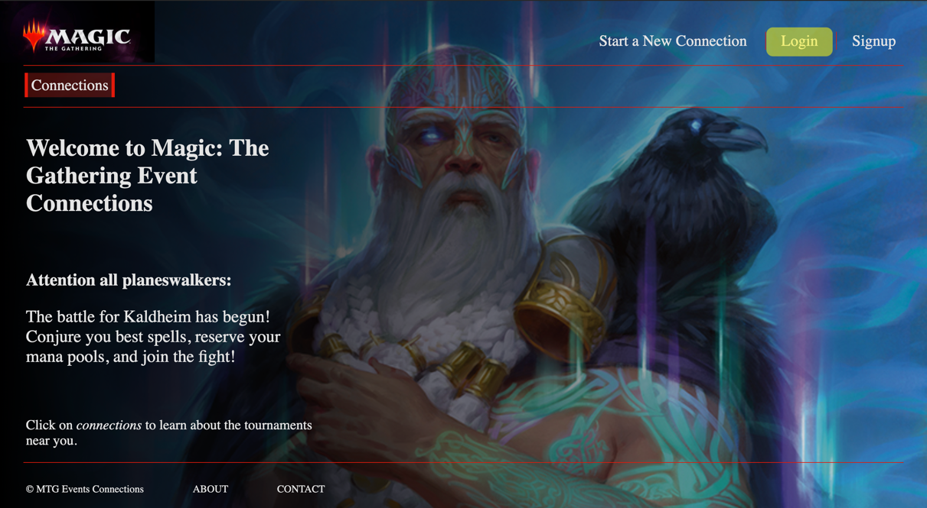

Once on the login page, the user will enter their email and password, then hit the login button.

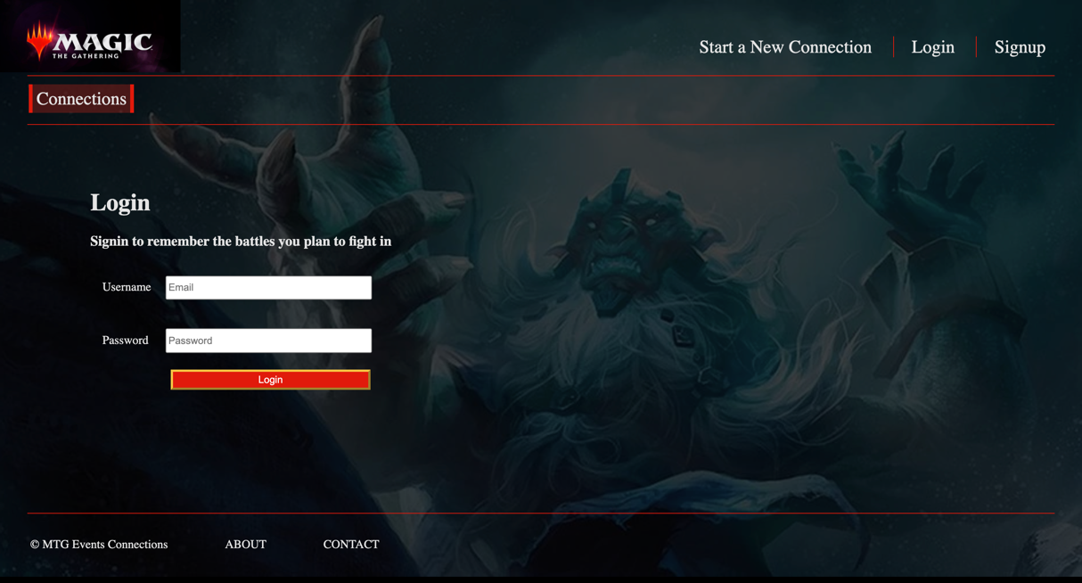

If the user’s email and password are correct, they will be redirected to the saved connections page.

**Sign Up:**

If the user does not currently have an account, they can sign up for one. To sign up for an account, the user will click on the signup button in the top-right of the screen.

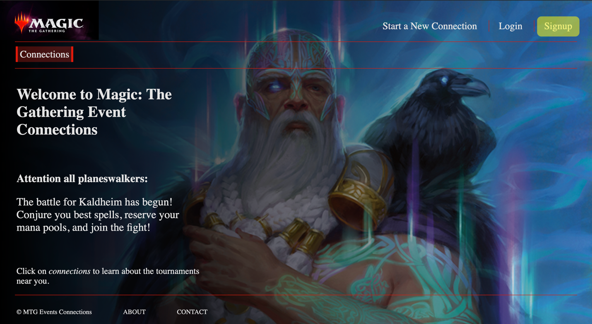

Once on the page, the user will fill out the fields and click the sign up button.

Note: The first name, last name, email, zip code, password, and password confirmation are required. The other address fields are not required.

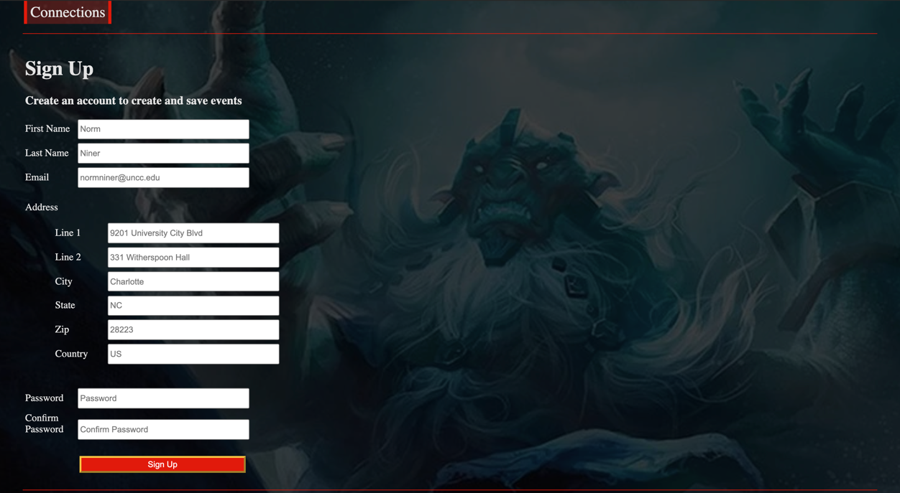

When the user clicks the sign up button, their account will be created, they will be logged in, and redirected to the saved connections page.

**Finding Connections:**

To find upcoming connections, the user will click on the connections button in the navigation bar.

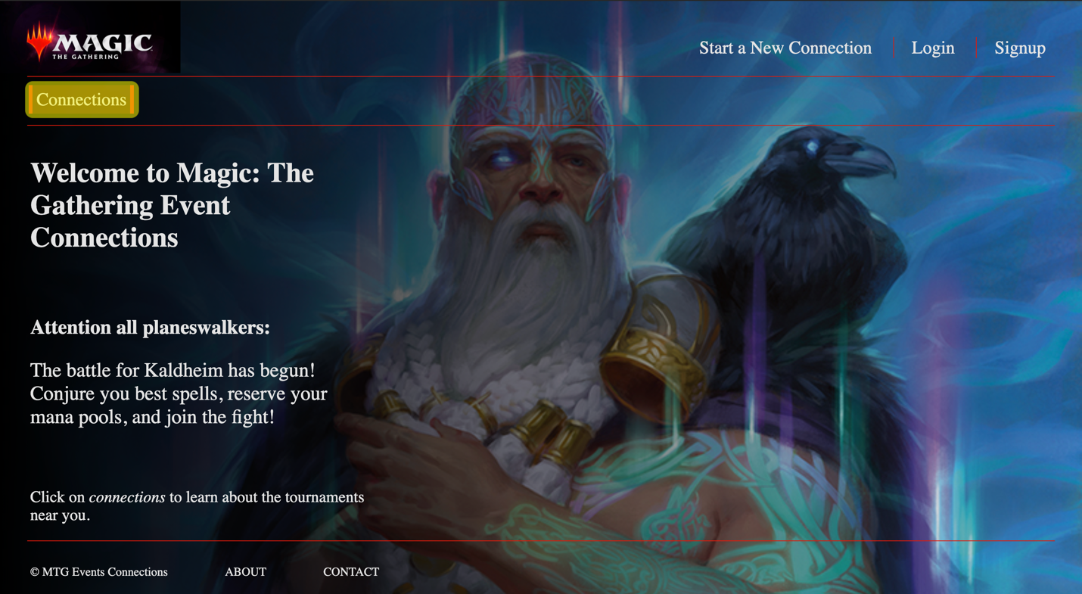

The user will be directed to the connections page below. The names of the connections can be clicked to see details about the specific connection.

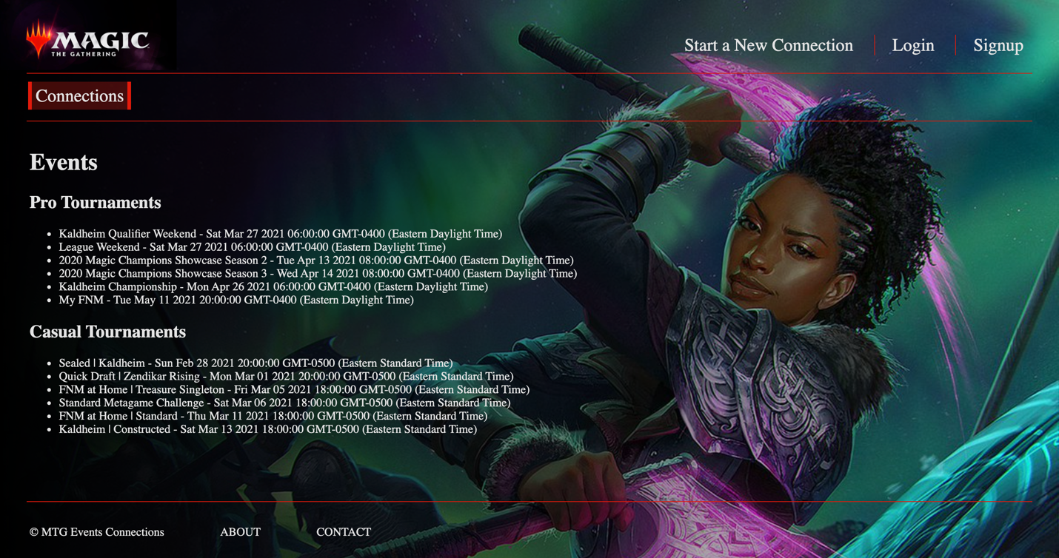

**RSVP to a connection:**

When a user finds a connection they want to attend, they can RSVP to the connection with yes, no, or maybe. To do so, they will click on a connection from the connections page. They will be directed to a page that is similar to the one below.

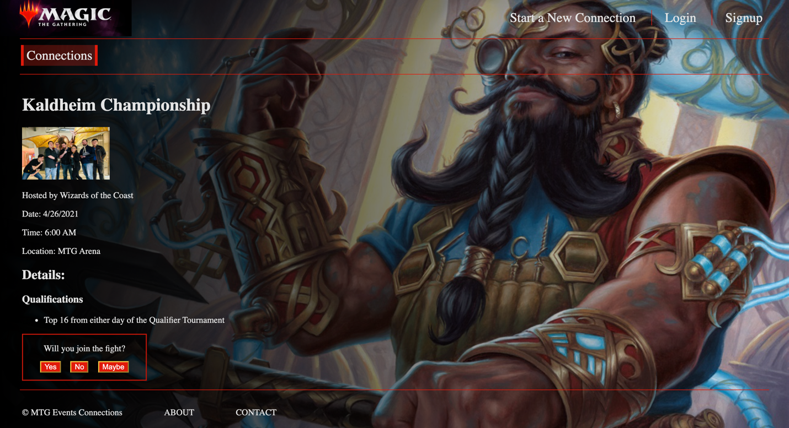

Once on the page, the user will click on the yes, no, or maybe button depending on which RSVP best reflects the intended status of their attendance. After clicking on any of the three buttons, the user will be redirected to the saved connections page where they can see their newly added connection.

**Update a RSVP’d Connection:**

After a user has RSVP’d to a connections, they might want to change the status of their RSVP. To do so, the user will navigate to the saved connections page by clicking on “My Connections” or their username(see below).

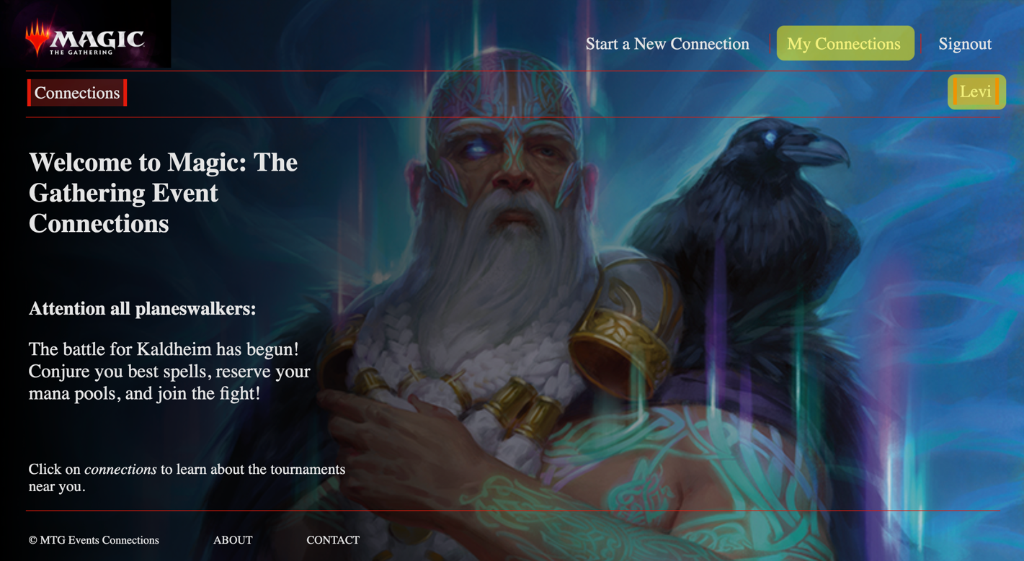

Once on the saved connections page, they will see a screen similar to the one below.

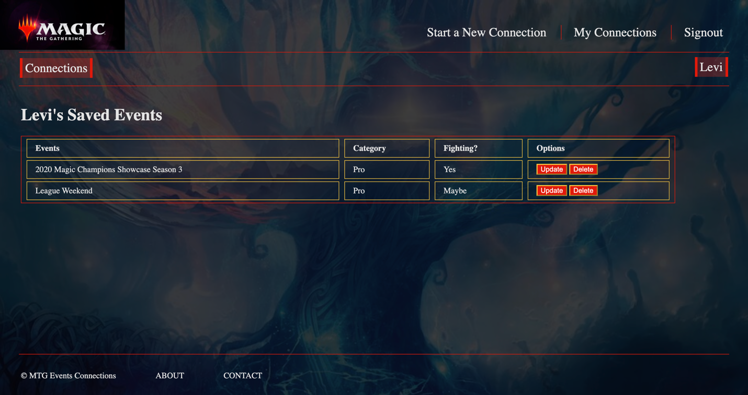

To update a connection RSVP, the user will click on the corresponding update button. Clicking that button will redirect them to the connection details page. On the details page, the user can update their connection in the same way they RSVP’d to the connection the first time.

**Delete a RSVP’d connection:**

After a user has RSVP’d to a connections, they might decide they no longer want to attend. In order to remove their RSVP, they will need to navigate to the saved connections page and click on the corresponding delete button. This process is similar to updating a RSVP, except the user is not directed away from the saved connections page.

**Create a New Connection:**

When a user decides they want to host their own connection, they will need to create one to share with everyone on the website. To create a new connection, the user will need to navigate to the new connection page by clicking the start a new connection link in the header (see below).

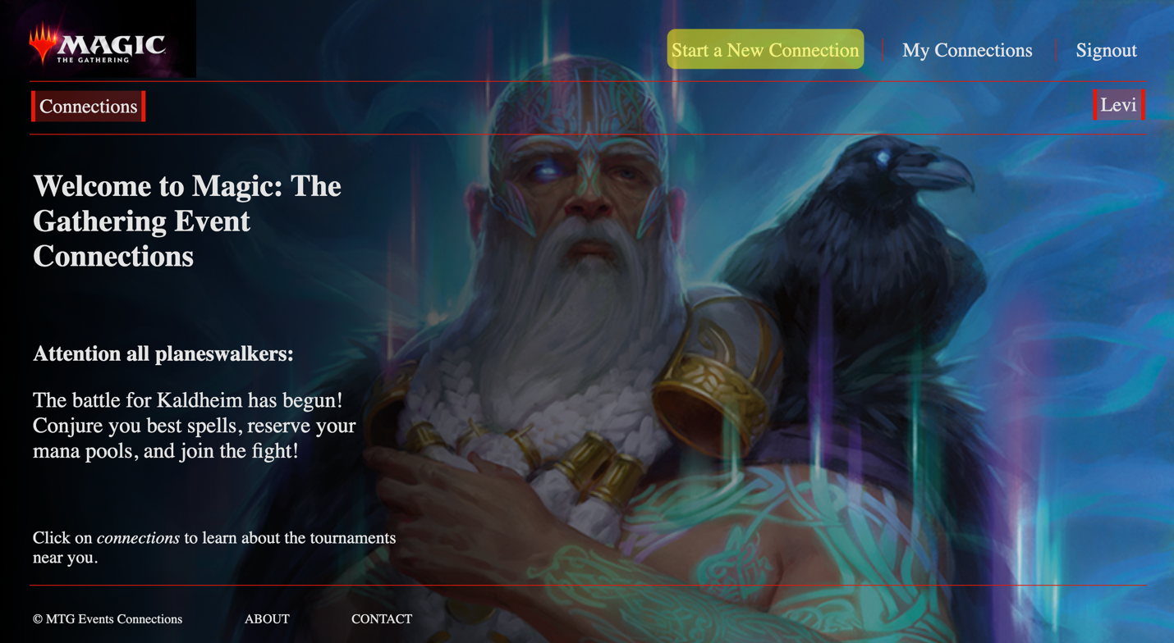

Once on the new connection page, the user will fill out all the fields with the information about their event, then click on the create connection button.

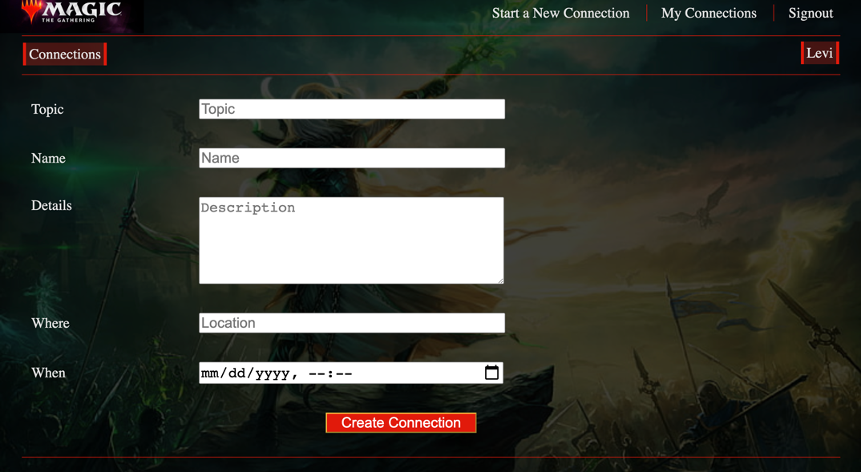

When they click on the create connection button, they will be redirected to the saved connections page where they can see the connection they just created.

Note: The user-created connections will have a red background as opposed to the normal transparent. See below.

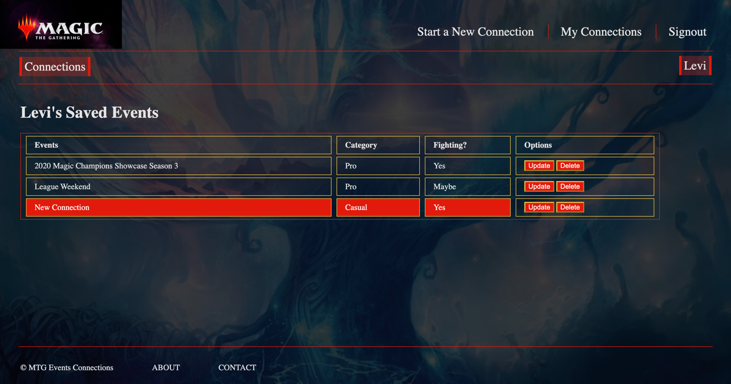

**Update a User-Owned Connection:**

After a user creates their own connection, they might need to update information about the connection. In order to do so, they will navigate to the saved connections page and click the update button that corresponds to the connection they want to update (the connection has to have a red background, otherwise only the RSVP can be updated. See the Update a RSVP’d Connection above for more information). Once the button is clicked, the user will be redirected to the new connection page with all the data fields auto-filled with the connection-to-be-updated’s details.

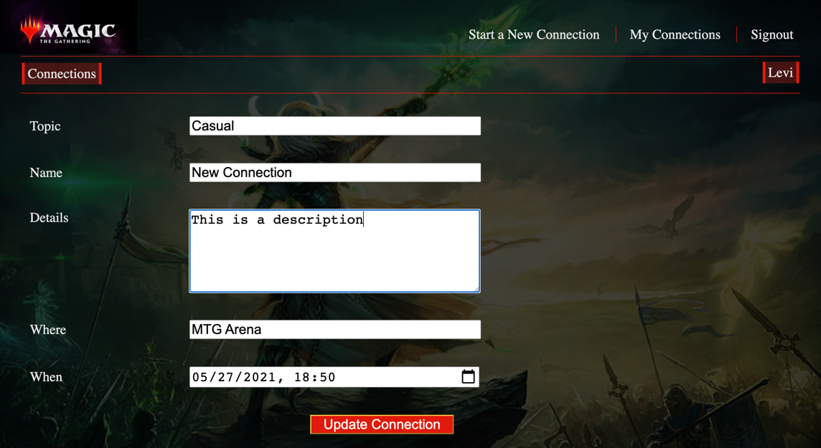

The user can edit all the details that needed to be updated, then click the update connection button. This will update the connection and redirect the user to the saved connections page.

**Delete a User-Owned Connection:**

After a user creates their own connections, they might decide they can no longer host the event and need to delete it. In order to do so, they will navigate to the saved connections page and click the delete button that corresponds to the connection they want to delete. Once the connection is deleted, it will no longer be available to any user.

Note: The connection needs to have a red background, otherwise only the RSVP is deleted. See the Delete a RSVP’d connection for more information.